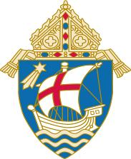
Diocese of Salt Lake City

Office of Safe Environment

“Opt Out” Form

The Diocese of Salt Lake City offers training to children on Safe Environment. Some parents/guardians may prefer to provide this training to their children. By completing this form, parents/guardians choose for their child(ren) NOT to participate in the Diocesan training. This election remains in effect until revoked by the parent. This form is retained by the local DSE.

Child’s Full Name: ____________________________________________________

School/Religious Education Program: ________________________________________

Parish/School/Organization: __________________________________________

Grade/Class: _____________________________________________________

Please verify by initialing the following statements:

_____ The Safe Environment Program was offered to my child.

_____ It is my choice that my child not participate in the program.

_____ I have received materials from the parish, school or program for
me to use to instruct my child on this topic.

Name of Parent or Guardian: ______________________________________________
(Please print clearly)

Signature ___________________________________ Date ___________________

Please return signed form to:

Name/Title: _______________________________

Address: _______________________________

